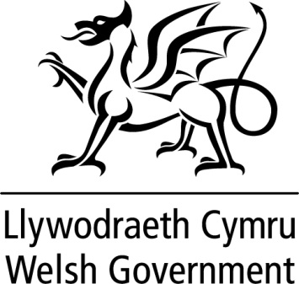

**WRITTEN STATEMENT**

**BY**

**THE WELSH GOVERNMENT**

|  |  |
| --- | --- |
| **TITLE** | **Additional funding to aide transition from Schools Challenge Cymru and support sustained improvement in the most challenged schools** |
| **DATE** | **11 January 2017** |
| **BY** | **Kirsty Williams AM, Cabinet Secretary for Education** |

Schools Challenge Cymru was developed as a time-limited intervention to accelerate improvement in our most challenged schools with funding to support a third year of the programme identified up to 31 March 2017. The design of the programme for the third year was developed in this context, with planning and subsequent implementation taking place at several levels to facilitate a smooth transition and support sustained improvement.

To further aide transition arrangements, we are extending the advisory support element of the programme to align with the end of the current academic year. As part of the Final Budget 2017-18, an additional £200k has been secured for 2017-18 to enable the continuation of high quality advisory support to the Pathways to Success schools.

The final report for the evaluation of Schools Challenge Cymru will be available later during the Spring Term. However, in the meantime my officials will continue to work with the Education Consortia to ensure that we fully capitalise on the learning emerging from the programme.

This year we saw the highest percentage of our learners attaining five good GCSEs. However I am concerned that there remain significant variations between our highest and lowest performing schools. With this in mind, taking the learning from Schools Challenge Cymru, I have asked my officials to explore with the Education Consortia what additional targeted work could be undertaken to accelerate improvement in our schools. A further announcement will be made in due course.