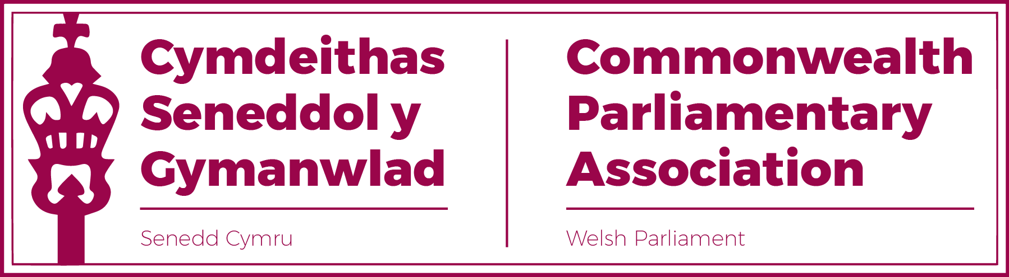

**BRANCH EXECUTIVE MEETING  
 6 July 2022**

**MINUTES**

PresentRhun ap Iorwerth MS, Chair  
David Rees MS (Vice-President)  
Delyth Jewell MS  
Alun Davies MS  
Rhianon Passmore MS  
  
SecretariatAl Davies, Acting Branch Secretary  
Enfys Roberts, International Relations Team

1. **APOLOGIES FOR ABSENCES**

Natasha Asghar MS  
Sam Rowlands MS

1. **MINUTES OF THE LAST MEETING** - Paper CPA 6S-22-01 (**DOC 1**)

The Minutes were accepted as an accurate record.

1. **MATTERS ARISING FROM MINUTES**

Matters arising from the Minutes had been actioned.

1. **REVIEW OF RECENT ACTIVITIES**

**Feedback and follow-up of recent Meetings, Visits,   
 Events and Conferences**

* *70th Westminster Seminar (****DOC 2****)  
  14- 18 March*The Seminar was attended by Sam Rowlands MS and Natasha Asghar MS and their report has been circulated.
* *51st BIMR Annual Conference (****DOCs 3****)  
  Isle of Man  
  23-25 March*

The Regional conference had been attended by the Chair as well as Natasha Asghar MS.  
  
Rhianon Passmore MS had attended the AGM and CWP Steering Committee virtually and had been elected as Regional CWP Vice-Chair, for which Branch Members congratulated her.

Branch Vice-President David Rees MS had unfortunately had to withdraw from the conference in order to cover Senedd Plenary duties.

The Conference had focussed on the theme of “*Impactful Scrutiny*”. There were, unusually, no external speakers but rather an opportunity from those delegates present to play a very interactive roles in proceedings and to discuss practice within their own legislatures.  
  
A summary report and other materials relating to the conference had been circulated.

* *CPA Mid-Year Executive Committee Meeting  
  Assam, India  
  9 April*Regional Secretary Jon Davies had circulated a summary of this International Executive Committee meeting which included discussions on:  
    
   -improving gender balance at CPCs and on ExCo;
* Future recruitment of a Secretary General.
* CPA Status in the UK, and that
* Trinidad and Tobago had been confirmed as hosts of the next Commonwealth Youth Parliament (CYP) in late 2022.  
    
  The Chair noted that the Senedd would, once again, hope to nominate Members from our Welsh Youth Parliament to represent our Branch of which there was support.
* *Visit by Western Cape Provincial Parliament (****DOC 4****)  
  3 May*

The Chair noted this positive visit, in which several Branch Members were involved. The Speaker-led delegation from the Western Cape had been very grateful and spoke warmly of the Senedd programme they received, which covered a range of sessions from the Welsh Youth Parliament to the work of the Finance committee. A short note of the visit had been circulated.

* *BIMR CWP Steering Committee Meeting  
  Virtual  
  6 June*

No Branch Members were present for this meeting, which the Acting Secretary had observed.  
  
The main discussion points had been the BIMR’s Inclusive Parliaments Project, Budget Planning and the next CWP conference.  
  
Note: Following the meeting, Helen Haywood (BIMR Secretariat) had stated that she sent details of BIMR CWP Meetings to all of our CWP representatives and in future, regardless of what current rotation arrangements were in place at the Senedd, all three of our Members could attend which would be preferable to no elected Members present, as had been the case at this meeting.

* *BIMR CPwD Meeting  
  Presentation: Access to Elected Office Fund  
  Virtual (led by Scottish Parliament)  
  13 June*Mark Isherwood MS, as our CPwD Champion, attended this meeting, led by the Scottish Parliament, which focussed on Access Funds for Parliamentarians with Disabilities.
* *BIMR Climate emergency Working Group Session (****DOC 5****)  
  Virtual (led by Scottish Parliament)  
  27 June*Llyr Gruffudd MS had unfortunately been unable to attend this session. However his Committee Clerk and Research officials were present to feed back. The session (again hosted by the Scottish parliament) focussed on Holyrood’s *Sustainable Development and Impact Assessment Tool.*

A note of the session has been distributed.

* *Visit by Ms Sonia Hornerey MP (NSW)   
  28 June*This visit by Sonia Hornerey MP from the New South Wales Legislative Assembly had included the opportunity to meet with Rhianon Passmore MS, Delyth Jewell MS, Natasha Asghar MS and Joyce Watson MS to discuss the Senedd’s representation of women and the work of the CWP.
* *Study visit by the Public Accounts Committee of the   
  Balochistan Provincial Assembly (Pakistan)  
  5 July*This visit, which had been many months in the making and rearranging, finally took place the previous day and included sessions with the Senedd’s PAC committee clerking team as well as with the office of the Wales Audit Office.  
    
  It was pleasing that several of the Branch’s Members had been able to meet the delegation over lunch.

5. **FORWARD PLANNING**

**Forthcoming Meetings, Visits, Events and Conferences**

* *Visit by Mr Adam Searle MLC, NSW Parliament  
  12 July*Mr Searle’s programme, the following week, would include meetings with Llyr Gruffudd MS and John Griffiths MS, having expressed an interest in the work of the Senedd committees which they Chaired.
* *BIMR Election Observer Mission Training Session  
  Virtual  
  14-15 July*Alun Davies MS, Delyth Jewell MS and DPO David Rees MS had expressed an interest in attending this Training Session the following week and the Chair noted how pleased he was that all three of our Members had been accepted to attend these sessions.  
    
  Afternote: David Rees MS was unfortunately unable to attend due to a clash with Senedd chairing duties.
* *65th Commonwealth Parliamentary Conference (CPC)  
  Halifax, Nova Scotia,   
  20-26 August*

The Chair noted that our final delegation for this year’s CPC had now been finalised with the following Members having been selected:  
  
**Sarah Murphy MS  
Laura Jones MS**  
**Huw Irranca-Davies MS**  
The Chair wished Sarah, Laura and Huw well at the CPC and the Branch looked forward to learning of their experience in due course.

Afternote:Laura Jones MS subsequently had to withdraw from attending the conference.

* *CPA UK – Inaugural Trade Workshop for Overseas Territories, Crown Dependencies and Devolved Legislatures.*

*Westminster  
13-15 September*The Branch had been invited to nominate up to two Members to attend this Workshop. Party Trade Spokespersons and Members of the *Economy, Trade and Rural Affairs Committee* had been prioritised for this opportunity though there could be further opportunities for other Members to attend also.

* *Visit by St Helena PAC Committee  
  21 September (tbc)*This provisional visit would be confirmed over the summer recess and Branch Members would be notified if the visit went ahead.  
    
  Afternote: This visit has since been rescheduled to take place in January 2023.
* *BIMR CWP Conference  
  Gibraltar  
  4-7 October*Dates had now been confirmed for the next BIMR CWP conference which would be hosted by the Gibraltar Branch.

The Senedd had been invited to send up to three Delegates as well as an accompanying Official.

Rhianon Passmore MS, Delyth Jewell MS and Natasha Asghar MS would, as the Branch’s Steering Committee Members, be prioritised for these opportunities in the first instance.  
  
Afternote: The Branch’s final delegation had been Rhianon Passmore MS, Heledd Fychan MS and Buffy Williams MS.

1. **NEW ITEMS / ANY OTHER BUSINESS**

**Senedd Proposal to host future BIMR conference**  
The Chair noted that, with the Senedd having last hosted a full BIMR Conference back in 2014, it was now timely to begin discussions around our hosting another conference later within this Senedd term.

There was overwhelming support from Members present that the Senedd should now consider putting in a bid to host a BIMR conference in either 2024 or 2025.   
  
The Chair explained that the Regional Conferences operated on a  
 “*he who hosts pays*” arrangement with considerable expense and work involved in hosting. It would therefore be necessary to raise this with the Llywydd (Branch President) and Manon Antoniazzi (Branch Secretary and CEX/Clerk) in order to ensure that the required funding and resources could be provided for us to host a successful conference.

7. **FUTURE MEETING DATE:**

October 2022 (TBC)

**END OF BUSINESS**