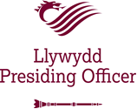

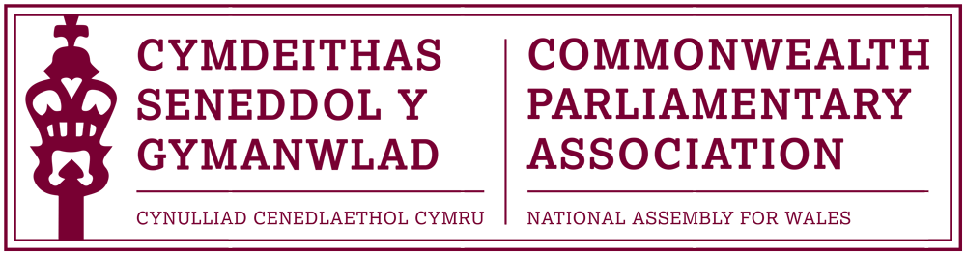

VISIT TO BOTSWANA & SOUTH AFRICA
- February – 1 March 2019
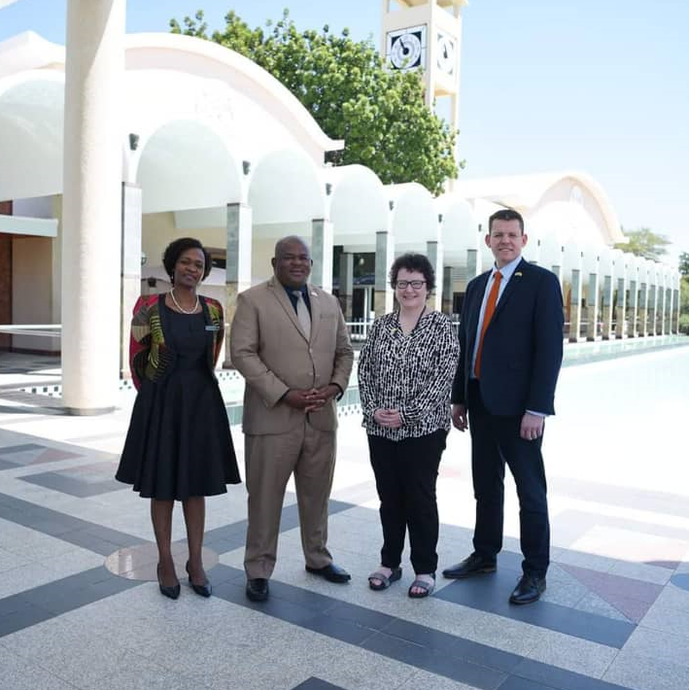

- Background and Overview

1.1 The Visit to the Botswana and Western Cape Provincial Parliaments took place between 26 -28 February 2019. The Visit was led by the Llywydd, Elin Jones AM and accompanied by Rhun ap Iorwerth AM -Chair of the National Assembly for Wales’ Branch of the Commonwealth Parliamentary Association (CPA).

The Visit was supported by Al Davies, Senior International & Protocol Manager.

  - The visit programme is attached in Annex B

- Visit to the Botswanan Parliament, Gaborone

2.1 The visit to the Botswana Parliament (BP) was instigated following an official invite to the Llywydd from the Clerk of the Parliament, on behalf of Speaker Kokorwe.

2.2 The focus of the visit was to evaluate the sustained and ongoing support which the Senedd has provided in a range of areas to the Botswana Parliament. The Welsh delegation was keen to learn more of this relationship, of how it could be further developed and of what lessons the Senedd, in turn, could learn from the Botswana Parliament.

2.3 It was of concern to learn, upon arrival in Botswana, that the Speaker of the Parliament of Botswana, Gladys K. T. Kokorwe MP had been taken ill and admitted to hospital. The Llywydd passed on her best wishes, on behalf of all at the National Assembly for Wales to Madam Speaker. The visit programme was consequently hosted by Deputy Speaker of the National Assembly, Hon. Kagiso P. Molatlhegi, MP; for which the Llywydd noted the delegation’s appreciation.

2.4 An informal welcome dinner was hosted by the Hon. Kagiso P. Molatlhegi, MP on 26 February. Also in attendance were selected Members of Parliament, as well as the Clerk of the Parliament, Ms Barbara Dithapo.

2.5 The official programme began on the morning of 27 February within the distinct and impressive setting of the Botswana Parliament buildings in Gaborone.

2.6 A short background briefing was provided on the Botswana Parliament, its history and current priorities. Botswana, a former British colony, had gained independence in 1966. Its parliament remains based on the Westminster model with a first past the post system and fixed five-year terms. The Parliament’s 63 Members were made up of 57 elected Members and 6 who were appointed. The Parliament’s next elections would take place in October 2019.
2.7 The delegation also learned of the role of the House of Chiefs which consisted of 35 Members. The Chiefs had no legislative powers but an important consultative role. The House of Chiefs met quarterly, a week before the parliament.
2.8 Mr Deputy Speaker noted that Botswana prided itself on being a peaceful nation and of having a stable democracy, founded on the principle of consensus.
2.9 There was interest in learning more in the Senedd’s Committee system and the Llywydd discussed how our Committee Chairs and Membership were selected. The issue of capacity in small legislatures and the necessity of Members being too thinly spread across committees was a mutual concern noted. The Llywydd however stressed the positive and dynamic influence of the Senedd’s Committees, through their independence.
2.10 The delegation learned more of the Botswana Parliament’s six-year strategic plan with an overall objective of realising a core mandate of good and accountable governance.
Priorities and Challenges for the Botswanan Parliament were
noted as:
- Upskilling Parliamentarians.
The Llywydd was pleased of the opportunity to discuss the pioneering work of the Senedd’s Members’ Professional Development Service and was aware that its reputation had garnered interest in this service internationally, of which the Senedd was proud. We were happy to provide further details of this service and how a similar model might be adapted for the BP’s needs.
- Further developing the Research Service
There was a recognised need to enhance capacity and develop in-house specialists, deemed integral to the effective scrutiny of parliamentary function.
The Llywydd stressed the importance of Members in Wales being able to access effective and impartial independent research. It was a service area in which the Assembly commission had invested in heavily over the years and which was clearly paying dividends.
- Developing Operational Autonomy
Separation was required from the Civil Service which supported the Executive with dedicated staff for the legislature. The BP Staff currently worked very long hours in multiple roles which included assisting Members with their casework. This was not deemed sustainable in the long-term.
- Citizen Engagement and Broadcasting of the Parliament
A key aspiration was to counter public apathy and to engage the people in the work of the parliament – agreed by all as being “a big issue with old challenges” for both our legislatures. There was however noted to be much positive activity by the BP, including the “Taking Parliament to the People” initiative led by Madam Speaker, which was not dissimilar to the Senedd@Outreach Programmes undertaken by the Assembly to numerous towns and cities outside the capital, Cardiff.
Another directive of interest had been “Botswana Speaks”, a web- based initiative rolled out to 27 constituencies to encourage citizens to raise issue of concern.
Mr Deputy Speaker considered that a key milestone to garnering support and increased interest in the Parliament would be through Broadcasting its Plenary and Committee Meetings. Whilst there was some reluctance to this, there was considered to be a positive relationship with the Media and a growing enthusiasm from stakeholders for broadcasting parliament.
A discussion on the merits of broadcasting one’s democracy followed with Rhun ap Iorwerth AM able to give a perspective as both a parliamentarian and former journalist. The Llywydd noted that the Assembly’s proceedings had been broadcast from day one of our democracy. Members had been quick to take advantage of Senedd TV’s evolution; being able use it as part of their twitter feeds was now proving popular and effective. The delegation encouraged the BP to broadcast its proceedings and was pleased to offer technical assistance in achieving this.
2.11 Official gifts were exchanged between the Llywydd and Deputy Speaker Molathegi as well as by Rhun ap Iorwerth AM, who presented bilingual copies of the children’s book “Alfie and the Dragon“ by author Tony Roberts, from his Anglesey constituency.

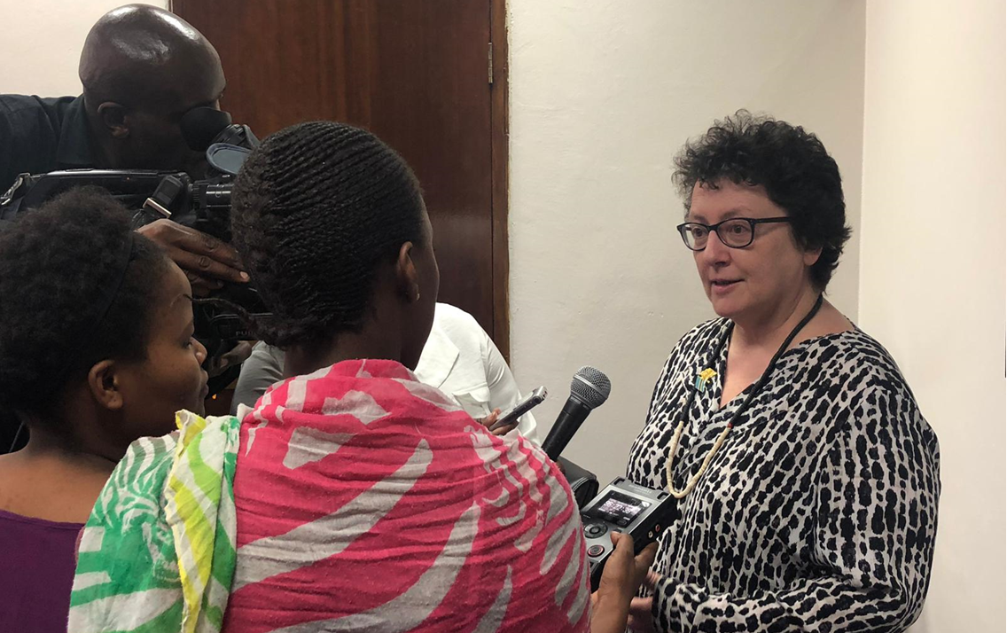
2.12 Media
There was a considerable media presence during the official meeting with Mr Deputy Speaker and it is understood that the Welsh visit was covered on both Botswana national TV and radio stations. The Llywydd was pleased of the opportunity to give interviews to the journalist present and discussed her thoughts on the importance of the Senedd’s international relations, and of the positive engagement between Wales and Botswana.

2.13 Commonwealth Parliamentary Association (CPA)
A meeting with the Chair and representatives of the CPA Botswana Branch followed. CPA Wales Chair, Rhun ap Iorwerth AM, discussed with counterparts’ current activities and priorities for our Branch and Region. There was also an opportunity to discuss CPA governance more generally.
It was noted that CPA Botswana had an active Branch and had hosted a successful Regional Africa Conference in Gaborone the previous summer. With 18 Branches represented and some 460 delegates, this was on an altogether different scale to any conference hosted by our own BIM Region and quite an undertaking for a Branch so similar in size to Wales. Indeed it was noted that the Africa Regional conference was on a similar scale to that of the Commonwealth Parliamentary Conference (CPC) held annually for the CPA in its entirety.
The meeting also included discussions on the role and engagement of the Commonwealth Women Parliamentarians (CWP) – the Botswana parliament has a disappointingly low number of Women Parliamentarians (6- fewer than 10%) and was keen to learn more of the Senedd’s positive experience of women’s’ representation and of how this had been achieved. Also discussed was the important role which our respective Branches’ had in engaging with young people through the CYP and other associated programmes.
It was noted that both our Branches would be represented at this year’s forthcoming CPC in Kampala, Uganda.

2.14 Tour of the Botswana Parliament Library
As part of the tour of Parliament, a visit to the BP Members’ library promoted interest by the Welsh delegation in the way in which parliamentary records could be filed in order of matters relating to specific constituencies. As a follow-up to this, the Senedd’s ICT department has been contacted to see whether similar filters could be applied to our own records for ease of use by Members in Wales.

2.15 Meeting with Madam Clerk, Ms Barbara Dithapo
The Clerk of the Parliament, Ms Barbara Dithapo, provided a useful presentation on the key findings to date on engagement with the Senedd. A summary of findings and actions from the past visits to Wales are detailed below.
Note: A full copy of the clerk’s report on engagement between the Welsh and Botswanan Parliaments is included in Annex A)
- There is need to provide adequate resources to facilitate the work of Parliamentarians.
- The Research service should be both proactive and reactive
- Parliamentary services should be integrated, allowing for maximization of resources and effectiveness of services
- The Research service should seek to create balance when dealing with different interest groups in order to address trust issues.
- When scrutinizing legislation, cost and negative/positive implications should be adequately considered and highlighted.
- Stakeholder engagement should be part of all parliamentary engagement strategies and ensure that interest groups and citizens are engaged on all matters which affect them.
2.16 The Welsh delegation were pleased of the opportunity to end their visit to the Botswana Parliament by attending that afternoon’s plenary session; and were honoured to receive an official recognition of their presence in the Chamber by Mr Deputy Speaker Molatlhegi.

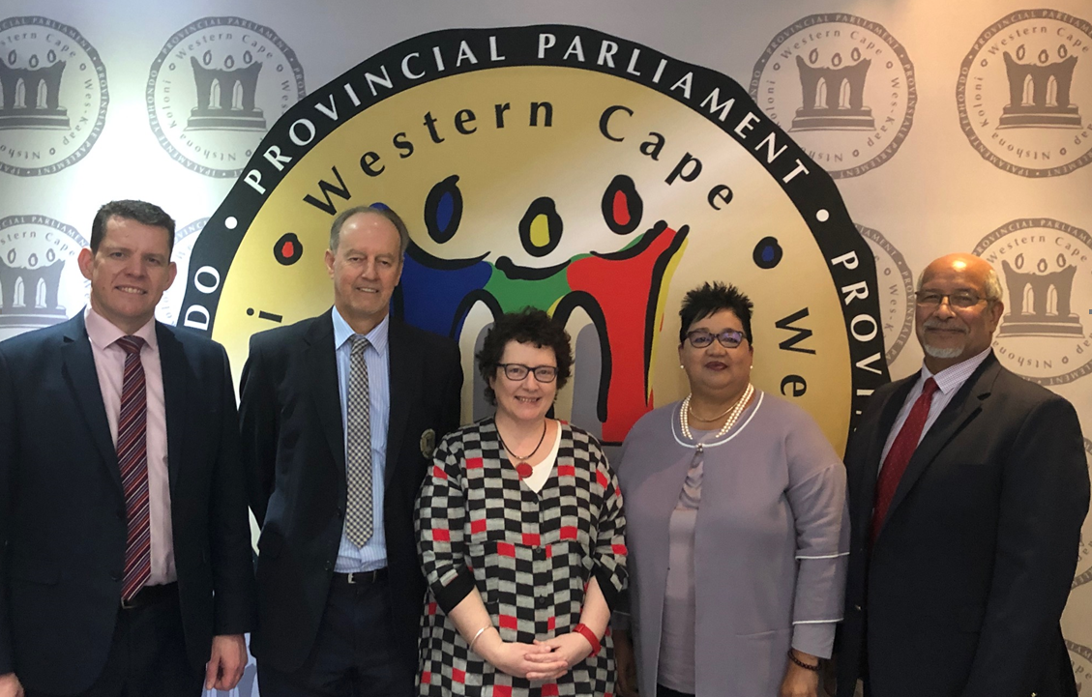
3. Visit to the Western Cape Provincial Parliament (WCPP)
Cape Town, South Africa

3.1 The Welsh delegation was warmly welcomed to Cape Town and to the Western Cape Provincial Parliament (WCPP) by Speaker Sharma Fernandez.
It was noted that this was a Unicameral parliament of 42 Members (its senate had been abolished in 2006). The Western Cape was one of nine provinces in South Africa and the only one which has its own constitution.
3.2 As part of the discussion on the wider political landscape in South Africa, Madam Speaker noted the confusion caused by both the WCPP as well as the South African Federal Parliament being based in Cape Town. She and many within the Western Cape, as well as other parts of South Africa, would prefer to see the Federal Parliament relocate to Pretoria, but acknowledged that there was little prospect of this in the short term.
3.3 Madam Speaker noted how pleased she had been that two of her senior officials had taken the opportunity to visit the Senedd as part of a recent visit to the United Kingdom. That visit had allowed them the opportunity to learn more of the Senedd’s Public Engagement Strategy; a priority for both our Parliaments. Speaker Fernandez stated how impressed her officials had been with the Senedd and that she hopes one day to visit herself.
3.4 A discussion regarding devolution settlements, funding formulas and sometimes difficult relationships with respective central governments to secure fair funding was held. The many parallels between Wales and the Western Cape within this context was noted.
3.5 Examples of current powers over which the WCPP was lobbying included policing and its harbours.
3.6 Madam Speaker raised the issue of respect within Parliament and was keen to learn more of how this was dealt with at the Senedd. There was much interest in the Assembly’s Dignity and Respect Policy, which the Llywydd explained had been approved in May 2018 and was something of which she was personally very proud. It was agreed that officials would follow up on sharing the policy with the WCPP.
3.7 The issue of capacity within our respective parliaments also bore interesting comparisons. The population of the Western Cape had grown rapidly from just over 4 million to almost 7 million within the last 20 years whilst its representation remained at 42 Members. This was considered to be at least 20 short of what would allow the WCPP to operate effectively. The Welsh delegation discussed how that very debate was presently taking place within the context of current proposed Assembly reforms.
3.8 CPA and International Engagement
A discussion on the CPA Western Cape Branch and of the wider work and issues pertaining to the Africa region was of interest. Madam Speaker was keen to discuss the work, and some related concerns, of the Commonwealth Women Parliamentarians (CWP) within the Region. Rhun ap Iorwerth AM highlighted the positive work of the CPA Wales Branch and the constructive relationship enjoyed with the wider Region and the BIMR Secretariat. Discussed was the small but innovative Regional CWP conference we had hosted at the Senedd in 2017.
3.9 It was clear that the WCPP took its international engagement seriously and it was of interest to the delegation to learn more of the merits of other international networks in which it participated. These included the (USA based) National State Conference of State Legislatures (NCSL) annual summit, which included a comprehensive programme for international delegates.
3.10 Public Outreach and Citizen Engagement.
This meeting allowed an opportunity to meet with officials who had recently visited the Senedd. Khayalethu Mkunyana, spoke passionately about the WCPP’s Public Education and Outreach programme. It was noted that public engagement is a statutory requirement in the Western Cape and the commitment and enthusiasm with which this is provided was immediately clear.
3.11 The delegation was shown examples of the innovative resources (including education workbooks) used to deliver its outreach work. These were created whilst considering the demographic and local community linguistic needs of the team’s target audience. The team worked with local elected Members where practical and provided training on how to best engage with the Parliament’s committees and petitions process.
3.12 Youth Engagement
The Welsh delegation learned of the strong movement of Youth Activism within South Africa but that this was very political in nature and historically linked to the anti-apartheid struggle. June was designated as Youth Month in South Africa.
3.13 There was great interest to learn more of the work of the Welsh Youth Parliament. and the Llywydd relayed the success of the first formal meeting of the WYP, which had taken place in the Senedd Siambr, just a few days earlier.
There was an aspiration within the WCPP to develop its own Youth Parliament in the future.

4. Visit to the Federal South African Parliament
A short visit to the Federal Parliament, situated nearby in Downtown Cape Town, provided the opportunity to view that afternoon’s plenary.

5. Robben Island
The delegation undertook a short visit to Robben Island. An informative tour and presentation, led by Peter – a former political prisoners, gave an insight into life for prisoners detained on the island under South Africa’s brutal apartheid regime.

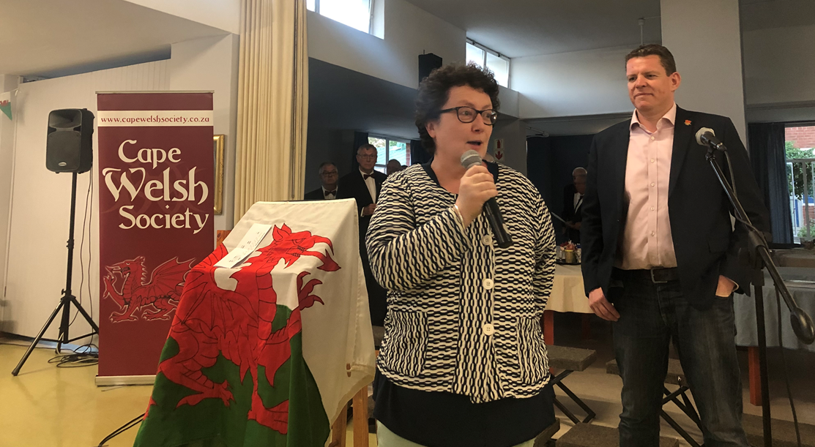
6. Engagement with the Cape Welsh Society – St David’s Day

6.1 The delegation was pleased of the opportunity to meet with members of the Cape Welsh Society and were invited as special guests to the society’s annual St David’s Day event. Both the Llywydd and Rhun ap Iorwerth AM addressed the audience which was made up of Western Cape residents who had previously lived in Wales as well as those of Welsh ancestry and guests from other Celtic societies in South Africa.

7. Conclusion and Outcomes
7.1 The visit, although short, was valuable. It was clear that the Senedd, the Botswana Parliament and the Western Cape Provincial Parliaments share many of the same issues and challenges. There is an appetite for further engagement and exchange of best parliamentary practice.
7.2 There is now considered to be a strong foundation in the relationship between the Senedd and Botswana Parliament as well as a a belief that this can be a meaningful and sustainable partnership. There is a joint will to establish a formal Memorandum of Understanding between our parliaments within the coming years.
7.3 The Senedd’s Public Outreach and Citizen Engagement strategy has been shared with the Botswana Parliament. Discussions are underway regarding the possibility of the Senedd’s Head of Public Engagement following up on this with training sessions at the parliament in Gaborone in 2020.
7.4 CPA Wales Branch Chair, Rhun ap Iorwerth AM, met with the Senedd’s Public Engagement team to discuss areas of good practice identified as part of the visit to Africa and of how some of these might be adopted as part of our own service. Noted in particular had been the excellent outreach work undertaken by the Western Cape Parliament and the impressive available resources to carry out this work.
7.5 There has been a range of follow-up actions between the Senedd and Western Cape Provincial Parliament. This has included sharing of the Senedd’s Dignity and Respect Policy (with a view to this being used as a template for a future policy at the WCPP).
A presentation on the establishment and development of the Welsh Youth Parliament has also been shared.
Madam Speaker Fernandez has been invited to lead a future delegation from the WCPP to the Senedd for a formal parliamentary programme. The WCPP Communications and Engagement team have also been invited to visit the Senedd to observe and learn from a future formal meeting of the Welsh Youth Parliament.
7.6 The Llywydd noted, following her visit to the Western Cape Provincial Parliament, how impressed she had been with the Parliament’s use of its logo as a backdrop for official photographs. Discussions have taken place to have something similar at the Assembly for use as part of the Llywydd hosting future international visitors at the Senedd.
8. Acknowledgement
The National Assembly for Wales would like to put on record its thanks and appreciation to all those from the Botswana & Western Cape Provincial Parliaments as well as the Cape Welsh Society for their time and kind generosity to facilitate the visit.

ANNEX A

CLERK OF THE NATIONAL ASSEMBLY’S BRIEFING NOTES ON THE OCCASION OF THE VISIT BY THE SPEAKER OF THE NATIONAL ASSEMBLY OF WALES (26/02/19)
- The Administration of the Parliament of Botswana is led by the office Clerk of the National Assembly.

- The Administration provides a range of administrative and support services and is made up of the following functional areas:

  - Parliamentary Counsel
  - Sergeant -At-Arms
  - Parliamentary Services
  - Corporate Services
  - Ntlo Ya Dikgosi
- The Parliament of Botswana is an active member of the international parliamentary community.

- By engaging in global and regional forums, the Parliament of Botswana has, and continues to build relationships with other Parliaments through a number of engagements, including visits and discussions on issues of common interest.

- The relationship between the Parliament of Botswana and the National Assembly for Wales (NAfW), which started in 2016, is one of those efforts aimed at supporting greater understanding and cooperation between the two parliaments.

- The friendship can be traced to the Westminster Foundation for Democracy (WFD) program which was initiated with a view to improve and inform policies and increase citizen participation in legislation and policy-making in Botswana.

- Launched in 2017, the two-year program with WFD sought to support research and information management in the Parliament of Botswana, while improving methods to engage citizens with the parliaments work.

- The genesis of the project is that at their core, Parliaments, including that of Botswana, are information intensive institutions. The technical capacity of parliamentary staff to support MPs in receiving clear, non-biased and accurate information is therefore vital for MPs to provide effective review of government proposals.

- Noting the importance of information to the work of Parliament, access to relevant information helps parliaments to develop responsive evidence-based public policies.
- An increased awareness and understanding of the role of Parliament with citizens is critical to strengthening public participation in the legislative process.

- By strengthening the National Assembly of Botswana’s procedures for the production and dissemination of research and information management, and developing the Parliament’s strategy to deliver better and effective communications, the Parliament of Botswana will be better equipped to provide effective research support to Members and to provide tailored outreach, education and engagement to citizens and stakeholders.

- The Speaker of the National Assembly Hon. Gladys K.T. Kokorwe was on a study tour of the NAfW in October 2016.
  - During the tour the Honourable Speaker met her counterpart, the Presiding Officer and Speaker of the NAfW, Llywydd, Elin Jones AM.
  - The two speakers shared best practices amongst Parliaments and sought to strengthen relations and consider how best to capacitate legislators and staff of Parliament so as to have an efficient Parliament.
  - The visit open avenues for the two Parliaments to consider capacity initiatives such as exchange programmes.
- Already, parliamentary staff from the Research and Library, Hansard, Public Relations, ICT departments and Committees units of the parliament of Botswana have been engaged on a number of occasions, including a visit to the NAfW in December 2017.

- The study visit was to appreciate the following from the NAfW:

  - The structure of the NAfW Research and information function
  - Learning and understanding how the Research function promotes, informs and educates Members of Parliament (MPs) and users of its products, including the innovative use of social media
  - How the Research Unit engages and utilises other research/information producing bodies such as think-tanks and universities, if at all, as well as the format and procedure of these engagement i.e. partnerships or assignment-based.
  - How and when the Research Unit works/supports other parliamentary bodies/departments particularly Committees and Public Relations
  - The use of Information Technology within research function
  - How to develop a parliamentary research service.
ANNEX B - Programme (Summary)

Tuesday 26 February
Evening
Official dinner hosted by the Deputy Speaker of the Parliament of Botswana, Hon. Kagiso P. Molatlhegi, MP
Wednesday 27 February
Programme the Parliament of Botswana
Morning
- Formal meeting with Deputy Speaker of the National Assembly, Hon. Kagiso P. Molatlhegi, MP
- Meeting with the Chair and representatives of the CPA Botswana branch
- Meeting with the Clerk of the Parliament, Ms.Barbara Dithapo
Afternoon
- Official recognition of the Llywydd and delegation at the Plenary session

Thursday 28 February
Programme at the Western-Cape Provincial Parliament (WCPP)
Morning
- Meeting with Speaker Sharna Fernandez
- Discussion of the political situation in the Western-Cape and relations with the Federal Parliament of South Africa with:
Piet Pretorius (Deputy Presiding Officer)
Mark Wiley (Democratic Alliance Party Chief Whip)
Pierre Uys (ANC Party Chief Whip)
- Meeting with the WCPP CPA branch representatives:
Speaker Sharna Fernandez
Hon Maseko
Hon Botha
Hon Beerwinkel
- Tour (and presentation) of the Parliament
- Meeting on Engagement with Citizens and Young People
Khayalethu Mkunyana - Public Education and Outreach Officer
Midday
- Official lunch hosted by Speaker Sharna Fernandez
Afternoon
Short programme at the South Africa Federal Parliament

Friday 1 March - St David's Day
Visit to Robben Island.
Evening:
Participation in St David's Day programme, in partnership with Welsh Cape Society

END OF PROGRAMME

