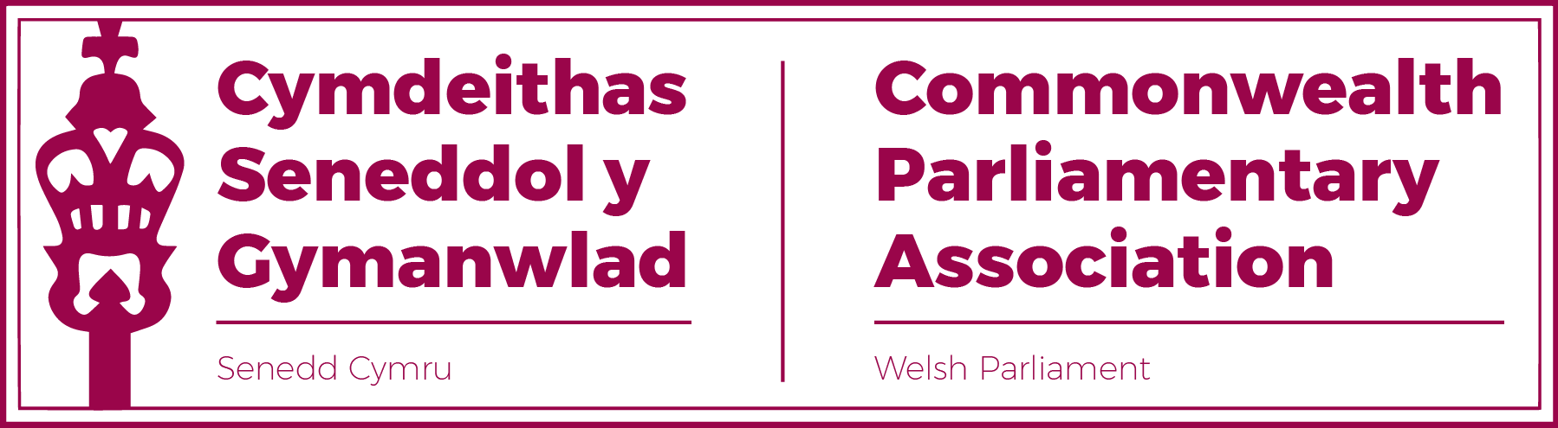

Minutes of the Senedd Branch

Annual General Meeting
23 November 2022

Welcome
The Branch Secretary (Clerk of the Senedd) welcomed those present and opened the AGM.

Minutes of Last AGM Meeting held on 16 September 2021

The minutes were accepted as a correct record.

Matters Arising

There were no matters arising.

Any Urgent Business

There was no urgent business

Report by the Senedd Branch Chair, Rhun ap Iorwerth MS

The Chair noted that it had been a productive one for the Branch. The Branch Executive Committee which, for the first time, was now gender balanced, had worked effectively and offered a dynamic and new perspective to our work. It had also been very positive to note the number of new Members, as well as those who had not previously engaged with the CPA in the past, take an interest in the work of the Branch. Some notable activities over this reporting period had included:

- Our participation in not one, but (unusually) two Regional Conference hosted by the Northern Ireland and Isle of Man Branches on the themes of “Post-pandemic Parliaments” and “Impactiful Scruitiny” respecitvely.

- Sam Rowlands and Natasha Asghar’s attendance at this year’s Commonwealth Parliamentary Seminar hosted by CPA UK.

Our participation in this year’s Commonwealth parliamentary Conference (the first in three years) hosted by the federal Canadian Branch in Nova Scotia where the Branch was represented by Huw Irranca-Davies and Sarah Murphy.

- A successful recent Regional Commonwealth Women Parliamentarians Conference held in Gibraltar on the theme of “Attracting and Retaining Effective Women Parliamentarians”, to which Rhianon Passmore led our delegation, accompanied by Heledd Fychan and Buffy Williams.

- The Chair referenced the important participation of Llyr Gruffydd MS as our representative on the Climate Emergency Working Group. Also, the excellent work led by Mark Isherwood MS as our Branch Champion on the Parliamentarians with Disabilities Network.

- The Chair expressed how pleased he and the Branch had been to see the CPA resurrect the Commonwealth Youth Parliament and that, following cooperation between the Branch and the Welsh Youth Parliament Team, the Senedd was at this very time being represented by former WYP Members Betsan Angell Roberts and Gwion Rhisiart in Port of Spain, Trinidad.

Closing

The Chair noted that 2023 promised to be an equally exciting year with planned conferences in Westminster and Ghana and that the Branch would also look forward to welcoming a variety of parliamentary delegation to the Senedd – from one of the smallest in St Helena to one of the largest in Canada.

The Chair thanked the Branch Secretariat for their support and looked forward to Members’ continued interest and engagement in the work of the CPA Senedd Branch.

6. Attendance:

Senedd Branch Members

1 Llywydd, Elin Jones MS (Branch President)
2. DPO David Rees MS (Branch Vice-President)
3. Rhun ap Iorwerth MS (Branch Chair)
4. Delyth Jewell MS (Branch Executive Committee)
5. Sam Rowlands MS (Branch Executive Committee)
6. Rhianon Passmore MS (Branch Executive Committee)
7. Natasha Asghar MS (Branch Executive Committee)
8. Mike Hedges MS
9. Peredur Owen Griffiths MS
10. Dawn Bowden MS
11. Sarah Murphy MS
12. Huw Irranca-Davies MS
13. Vaughan Gething MS
14. Mabon ab Gwynfor MS
15. Joyce Watson MS

Branch Secretariat:
Manon Antoniazzi, Branch Secretary, Chief Executive & Clerk of the Senedd
Al Davies, Acting Branch Secretary,
Enfys Roberts, Llywydd’s Private Office
Observing:
Gwion Evans, Llywydd’s Private Office

CPA Senedd Branch Secretariat

November 2022

